Support Afterschool in Illinois! |  | [Program Name]
 | [Mission Statement]
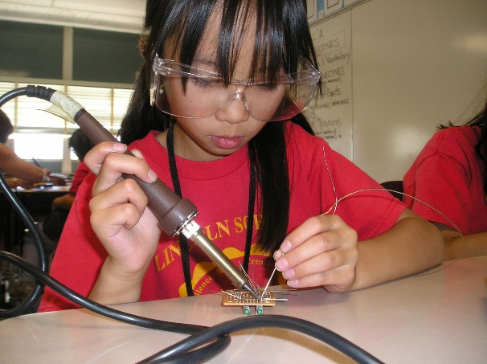 | The Need for Afterschool  Across America, 1 in 5 kids are alone and unsupervised from 3 to 6 p.m. These are the hours when juvenile crime and victimization peak—and many families and parents are still at work.¹  Despite clear support for afterschool programs, over 282,249 young people in our state remain alone and unsupervised in the afterschool hours. For every ONE Illinois student in afterschool, FOUR more would participate if a program were available.²  These children are not only unsafe and at risk--they are also losing out on important learning opportunities.

Afterschool Works!
Afterschool and summer programs help youth develop skills for the jobs of tomorrow, help youth make smart decisions and avoid risky behavior, and help youth learn and grow. ³ In afterschool programs, students learn by doing. They strengthen their communication, problem solving, and teamwork skills. Afterschool is a natural vehicle for career and skill exploration, project-based learning, interaction with industry, and exposing students to the opportunities that exist for them right here in Illinois.  Research shows that students in afterschool programs also demonstrate higher academic achievement, including improved grades, attendance, schoolwork, and behavior. Afterschool and summer programs can add 1,080 hours of academic learning to a child’s school year, equivalent to 144 school days.⁴  Afterschool programs also help support our current workforce by providing working parents peace-of-mind. Working parents are more likely to be able to maintain a sustainable work-life balance when they know their kids are safe and engaged in fun learning opportunities.⁵  References:  1 Afterschool Alliance. (2014). America after 3PM: Afterschool programs in demand.  2 Afterschool Alliance. (2014). America after 3PM: Afterschool programs in demand.  3 Afterschool Alliance. (2020). America after 3PM: Afterschool programs in demand.  4 Afterschool Alliance. (2014). America after 3PM: Afterschool programs in demand.  5 Afterschool Alliance. (2014). America after 3PM: Afterschool programs in demand. |  |  | Participation in afterschool programs inspires children to learn and connect with each other, provides parents peace of mind while they are at work knowing their children are supervised, and gives students the skills they need to  land the jobs of tomorrow.
 |  |  | 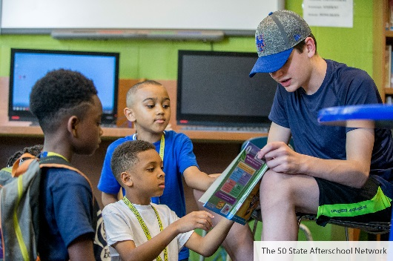

[PROGRAM NAME] contributes to the impact of
afterschool and summer programs by:
- Increasing youths’ learning potential through additional educational opportunities
- Reducing crime and juvenile delinquency by providing a safe space for youth to explore their interests
- Improving career readiness through workforce development programs
- [ADDITIONAL CONTRIBUTION]
- [ADDITIONAL CONTRIBUTION]
Since [YEAR], [PROGRAM NAME] has served youth ages ______in the _________ neighborhood/region of________, Illinois. The youth served represent a community that is ___% Black, ___% Hispanic or Latino, and ___% White. Nearly ___% of youth in the community receive free or reduced-priced lunch.
[TYPES OF PROGRAMMING/SERVICES OFFERED]

[INDIVIDUAL PROGRAM EVALUATION DATA/COMMUNITY-SPECIFIC DATA/STATE-SPECIFIC DATA]

[ANY ADDITIONAL PROGRAM INFORMATION]
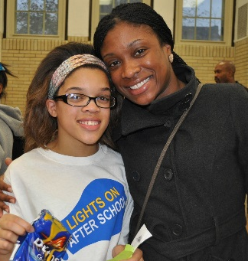 | [QUOTE FROM PARTICIPANT, PARENT, OR STAFF]
For the sake of Illinois’ youth,  I urge you to support afterschool programs! | [Opportunities for Collaboration/Specific Ask]  - Support our afterschool advocacy efforts, such as securing funding streams (e.g. 21st Century Community Learning Centers and the Teen REACH program).  - You can also lend your voice and expertise by participating in an [PROGRAM NAME] event as a speaker or attendee.  - Business partners can connect with [PROGRAM NAME] to facilitate opportunities for volunteering and to share their professional expertise with students hungry for career knowledge.  - Join us for a site visit or meeting to further discuss the afterschool needs in our community.  - [add/replace bullet points with relevant opportunities for collaboration]

